Microsoft Word APA 7th Edition

I. Formatting Pages

To Set Font: Make sure to change font size is set to 12 Times New Roman
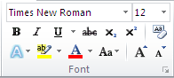

To Set Margins: Make sure margins are 1” inch top, left, bottom, and right
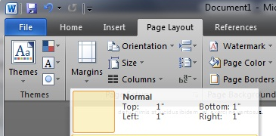

To Set Line Spacing:
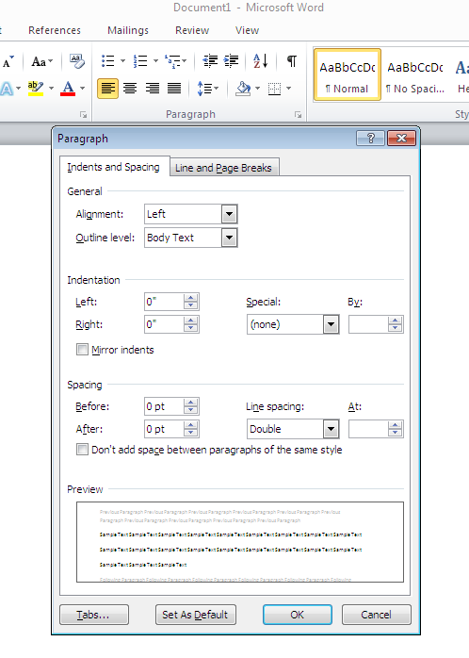

II. Title Page:

Double click margin area

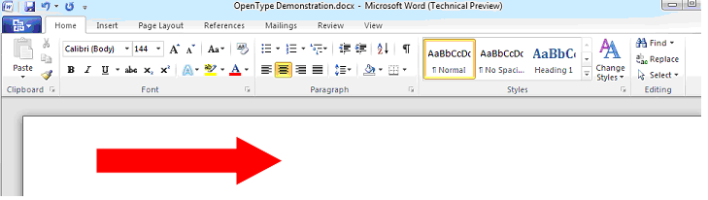

Insert “Page Number” click “Plain Number 3”

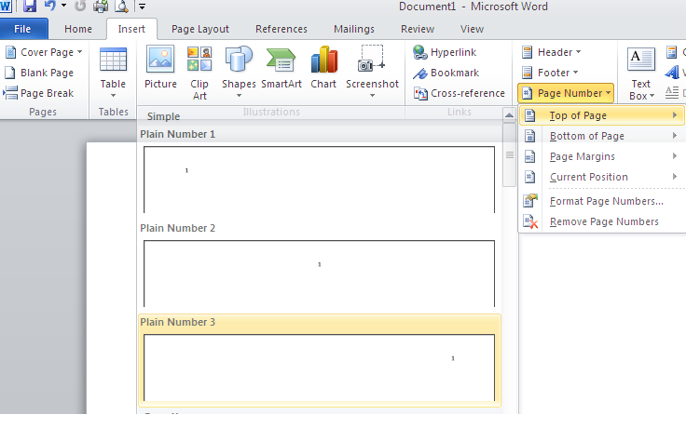

Make sure you hit the space bar once and hit “Tab” key twice!!!!
Then click “close header and footer”
Press the “enter” key 5 times

Center Your Title!!!!

This is an example of how your first page of your research paper should look like.

How To Research Properly Using APA Style

Azure College

Eng101: English Composition
Dr. Marva
October 1, 2019

Paper Title
Name of College
Course Name
Instructor’s name
Due Date of Paper

III. Abstract - one paragraph that contains the most important elements of the paper. It begins on a new page and should not exceed 150- 250 words. The label “Abstract” should be centered at the top of the page. Type the abstract as a single paragraph, left aligned without paragraph indentation. (no tab) All numbers in the abstract (except those beginning a sentence) should be typed as digits rather than words.

See example
Abstract

The End of Life Nursing Education Consortium (ELNEC) curriculum has been proven effective where it has been implemented. However, at the associate degree level, the ELNEC curriculum focusing on communication skills and their effect on the attitudes toward care of the dying has not been evaluated. This pilot study has identified the need for further research at the associate degree level to ensure quality care to patients at the end of life.

IV. Body of The Paper

The body of the paper begins on a new page. Subsections of the body of the paper do not begin on new pages. The first line of each paragraph is indented ½ inch (1 tab) from the left margin.
- Headings

Headings are used to organize the document and reflect the relative importance of sections.
- Main (first level) heading use centered uppercase and lowercase letters (e.g., Method, Results, References).
- Subheadings (second level headings) are italicized and use flush left, uppercase and lowercase letters (e.g., Participants, Apparatus, and Procedure as subsections of the Method section).

Citing Sources in your paper
As known as “In text citations”

- Reference Citations in the Text

In order to avoid plagiarism, all the sources you use in your research and papers must be cited both in text and in References at the end of the paper. In text citations and reference list must be identical.

Direct Quotes - When you quote someone, you must use “quotes” on the actual statement!!

Paraphrasing - is your own interpretation of what someone else wrote or ideas expressed.

Example(s)
- One author.

Dr. Duke (2011) describes her experience in Haiti as exciting and profoundly changing.

- Two authors

Saeger and Rudolph (2010) argue that professional ethics is important in alternative health care both for business success and for effective therapeutic relationship with clients (pp 93-95).

Short/Direct Quotations – when a direct quotation is used, always include the author, year, and page number as part of the citation. The key is to remember that all 3 elements of the citation – author, year, page number- must be given, whether in parentheses or as part of the sentence.

Example(s)

One Author

“The therapeutic touch had a great impact on the girl, whom many considered untouchable” (Madden, 2011, p. 2)

“The children are such eager learners!” (Duke, 2011, p.10)

Two Authors

“Interpersonal dynamics exist in all relationships, and they are a normal and necessary part of a therapeutic relationship between client and practitioner” (Saeger & Rudolph, 2010, p. 94).

Three to Five Authors – List all the authors in the signal phrase or in parentheses the first time you cite the source.

Example: note look example

In subsequent citations, only use first author’s last name followed by “et al”

No Author - If the work does not have an author, cite the source by its title in the signal phrase or use the first word or two in the parentheses.

***Please note only use “Anonymous” if listed as Author****

At Myorhythmics Massage & Bodywork our expert staff provides memorable therapeutic experience to our clients (“Expect,” n.d.).

The study revealed a strong positive correlation between the two variables (“Learn APA", 2006).

Long/ Direct Quotations – is a quote longer than 40 words where you indent the whole quote by ½ inch. Make sure the quote is double spaced as well. Do not put quotes markers around the quote

Example

Wright (1997) explains many educators support the integration of fine arts education:
These forms of learning, which are vital to the processes of expression and making meaning, should be central to the education experience. By making the arts the core curriculum, societies can begin to reaffirm their cultural role of
giving our lives a sense of identity, belonging and purpose (pp. 365-366).

III. Citing Sources at the “end” of the paper

The last page is called “References” and is “centered”

Bibliographic Citations

Printed books:

Author’s last name, first letter of first name. (Year). Title of book.
Publisher.

Make sure you insert hanging indents on the next line. See below how to insert one.

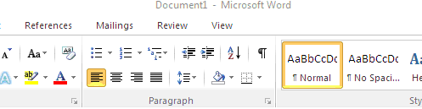
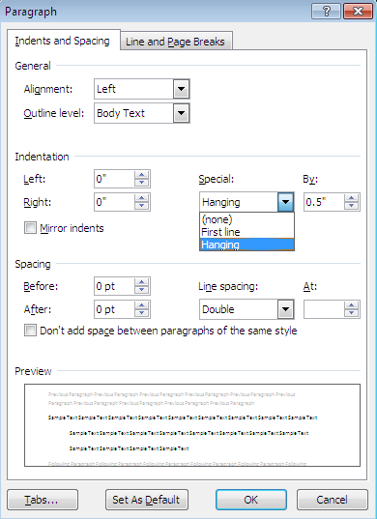

Example

One Author

Roberson, A. (2011). Politicization of ethnicity as a prelude to war: Croatia and Serbia in Yugoslavia. Lambert Academic Publishing.

Two Authors

Saeger, J.L. & Rudolph, L.S. (2010). Building a Healthy Business.
McGraw Hill

Three or Seven Authors - List by last names and initials; commas separate author names, while the last author name is preceded again by ampersand

Kernis, M. H., Cornell, D. P., Sun, C. R., Berry, A., Harlow, T., & Bach, J. S. (1993). There's more to self-esteem than whether it is high or low: The importance of stability of self-esteem. Journal of Personality and Social Psychology, 65, 1190-1204.
No Author - If the work does not have an author, cite the source by its title in the signal phrase or use the first word or two in the parentheses.

***Please note only use “Anonymous” if listed as Author****

National Center on Education and the Economy. (2007). Tough choices for tough times: The report of the New Commission on the Skills of the American Workforce. John Wiley &^ Sons.
Journal, Newspaper, or Magazine Article from Library Database
Author’s last name, first letter of first name. (Year, Month Day). Title of article. Title of Periodical, volume number(issue number), pages. (name of database)

Perkins, W.H, Linkenbach, J.W, Lewis, & M.A, Neighbors, C. (2010, October). Effectiveness of social norms media marketing in reducing drinking and driving: A statewide campaign. Oxford, 35(10), 866. ProQuest database

Dictionary
Author Title (Year of Publication). In Name of Dictionary. (ed) Retrieved (date you read it) (name of database or source)

Hepatoma (2009). In Mosby Dictionary of Medicine Nursing and Health Professions. (5th ed.). Retrieved September 5th, 2017 from Credo Reference Database
Internet Sources:

Websites “with” an author

Author’s last name, first letter of first name. (Year, Month Day). Title of Page/Document. URL
Smith R.C. (2000, June 1) Imari Obadele: The father of the modern reparation movement. http://www.hardford-hwp.com/archives/45a/312.html

Websites no author(s) and no date

Title of Page/Document. (n.d.). What causes Brain Cancer? http://myorthythmics.com/wte.html

Youtube video:
Author’s last name, first letter of first name. (Year, Month Day). Title of video [Video file]. url
Norton, R. (2006, November 4). How to train a cat to operate a light switch [Video file].
https://www.youtube.com/watch?v=Vja83KLQXZs
Blog
Author’s last name, first letter of first name. (Year, Month Day). [Web log post].
URL
Dr. Duke (2011, June 2). Teaching and learning… eager to learn. [Web log post].

http://timeout-drduke.blogspot.com/

Additional Citation help

Hacker, D. & Fister, B. (n.d.). Research and Documentation online (5th ed.).

http://bcs.bedfordstmartins.com/resdoc5e/

